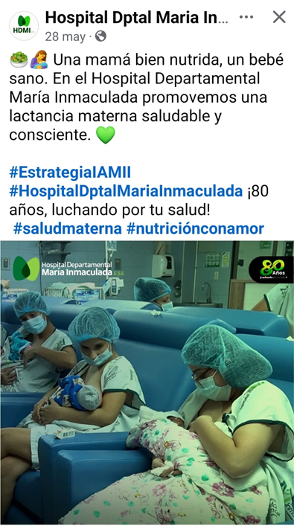 | https://www.facebook.com/share/p/1C4tdqY733/
SEMANA DE LA LACTANCIA MATERNA – AGOSTO
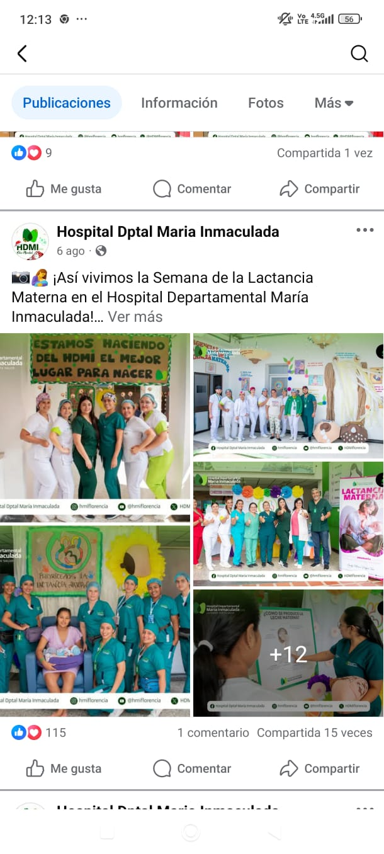

https://www.facebook.com/share/p/1DJGGNWTsu/

 | https://www.instagram.com/p/DNCR5Aft848/?igsh=MWQ2cXF6b3Bmb2trZA==
PARTO HUMANIZADO, DIGNO Y RESPETADO
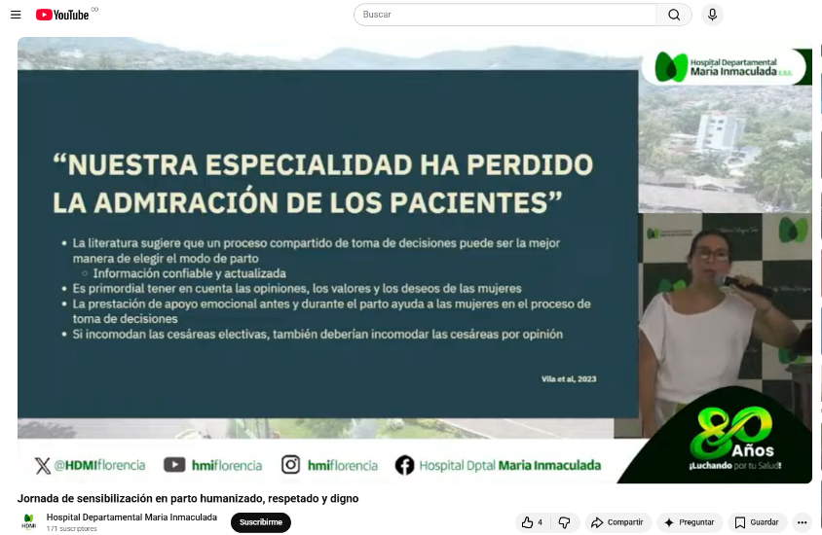 | https://www.youtube.com/watch?v=Eb_CxUPN2Eg&t=117s

