ACTIVIDADES DEL CONVENIO 179 CON LA FUNDACION ÉXITO Y EL PROGRAMA MADRE CANGURO.

FEBRERO
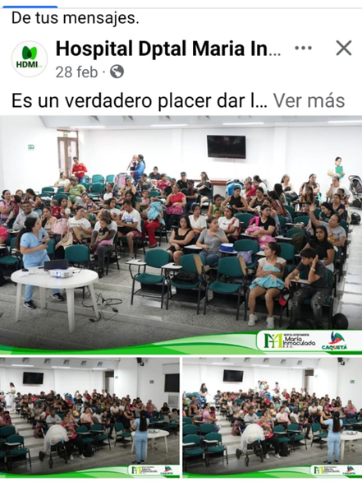 | https://x.com/HDMIflorencia/status/1895566384685596744?t=jDFR6v53McwofJuyFCgqKg&s=19
 | https://www.instagram.com/p/DGoRD4FB_-C/?img_index=2&igsh=cnc0NTQya3ExNjQ=
 | https://www.facebook.com/share/p/15xxE1BkQs/
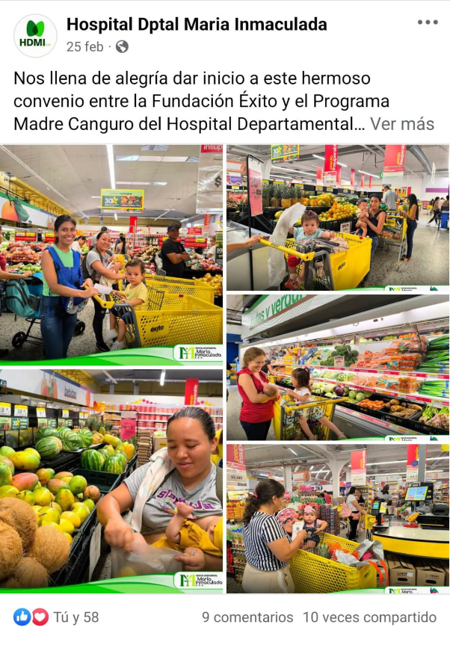 | https://x.com/HDMIflorencia/status/1894410472037679560?t=ovFrhmKzxpTyagWEge60tA&s=19
 | https://www.instagram.com/p/DGgFE0MgsId/?igsh=MjA0cDU4ZXp4c3p6
 | https://www.facebook.com/share/p/1YigxE5fn4/
MARZO
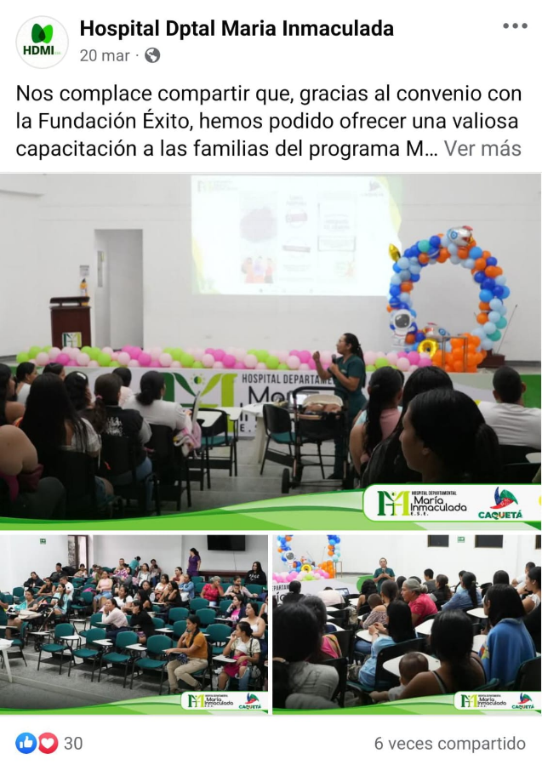 | https://x.com/HDMIflorencia/status/1902823646575341905?t=KsTko9mzhIKR-DtVSUn7ZQ&s=19
 | https://www.instagram.com/p/DHb1L8jBhsZ/?igsh=aGdsazZmcmV0Z3Rq
 | https://www.facebook.com/share/p/15pSHrAHyG/
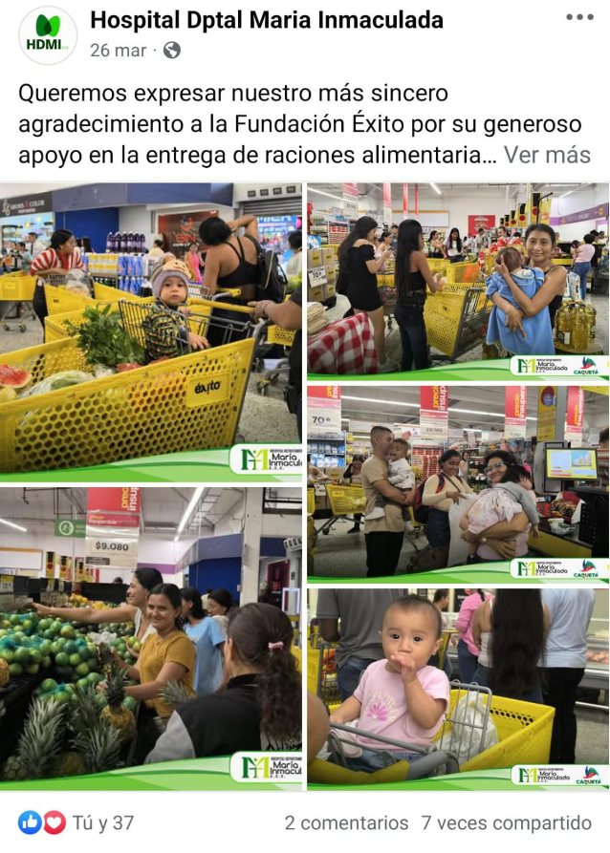 | https://x.com/HDMIflorencia/status/1904889827239112902?t=kbFTElMGq_TDtgXuK74aRQ&s=19
 | https://www.instagram.com/p/DHqggz7gBzT/?igsh=MW96M3V3c2hxN2g0OA==
 | https://www.facebook.com/share/p/1CJXXbufnx/
ABRIL
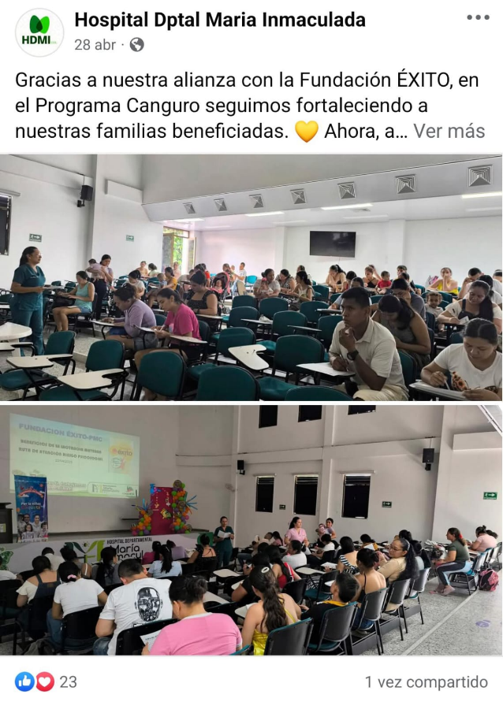 | https://x.com/HDMIflorencia/status/1917002891623125287?t=KOr4DI-DiS1mNuUEcdo86A&s=19
 | https://www.instagram.com/p/DJAlUlgtzyc/?igsh=ZmJrNGV3cXc4YTRl
 | https://www.facebook.com/share/p/1AfeedFbaw/
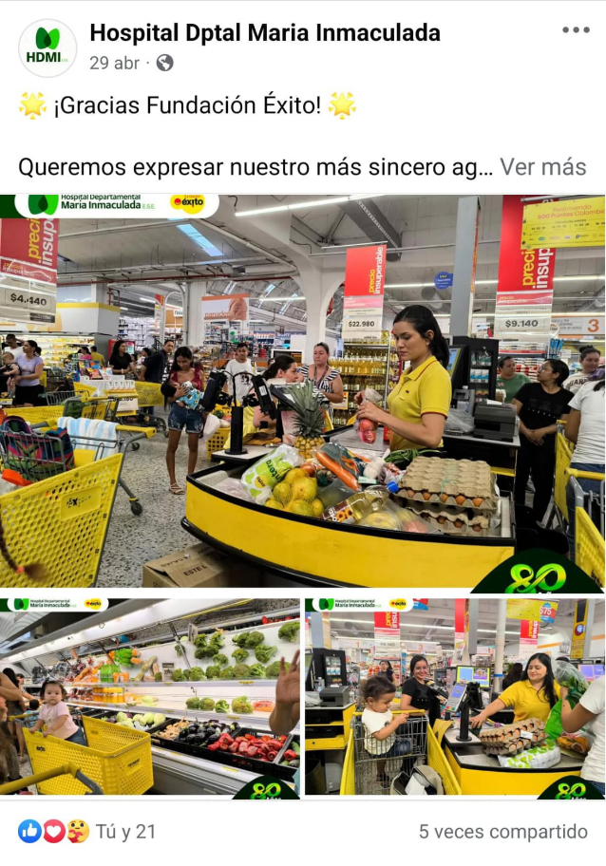 | https://x.com/HDMIflorencia/status/1917226996204966255?t=DtsfjaD_WNHwL5XQjWf1zA&s=19
 | https://www.instagram.com/p/DJCKLpPADEo/?igsh=MThpZmMwODFzazV6Zw==
 | https://www.facebook.com/share/p/1ZDxAwYsFC/
MAYO

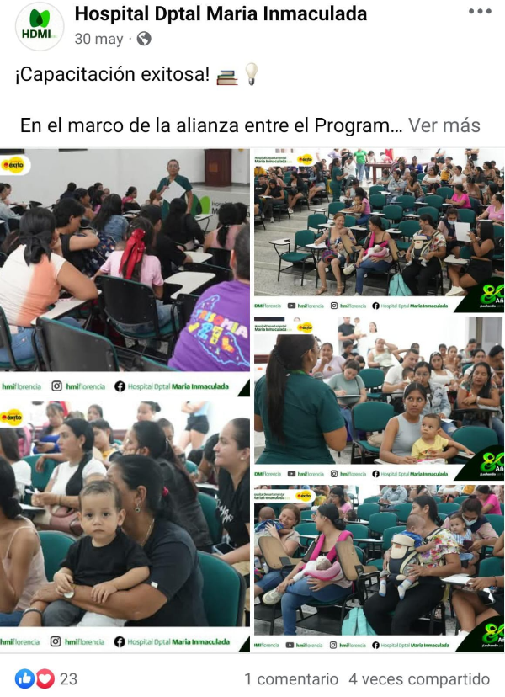 |  | https://x.com/HDMIflorencia/status/1928582030154981785?t=u1gprLM9Ol7DOfq4DZuOnA&s=19
 |  | https://www.instagram.com/p/DKS3Ahntoht/?igsh=MWQ1dDRvajR2c2Z1Mg==
 |  | https://www.facebook.com/share/p/15g6n8j1QE/
JUNIO
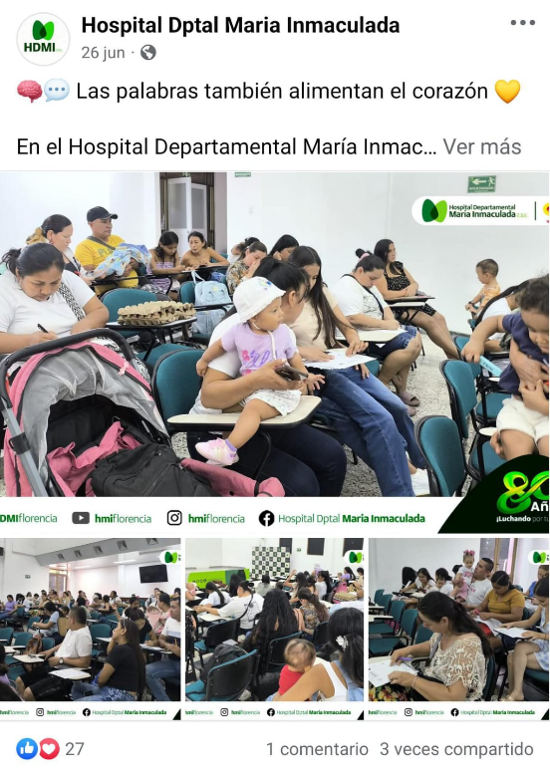 |  | https://x.com/HDMIflorencia/status/1938337009036091410?t=F_Vg9z53rhghkI0P3Qd_4w&s=19
 |  | https://www.instagram.com/p/DLYK6W7BIBG/?igsh=N21hcGppZjljejZ3
 |  | https://www.facebook.com/share/p/1C5FncatsV/
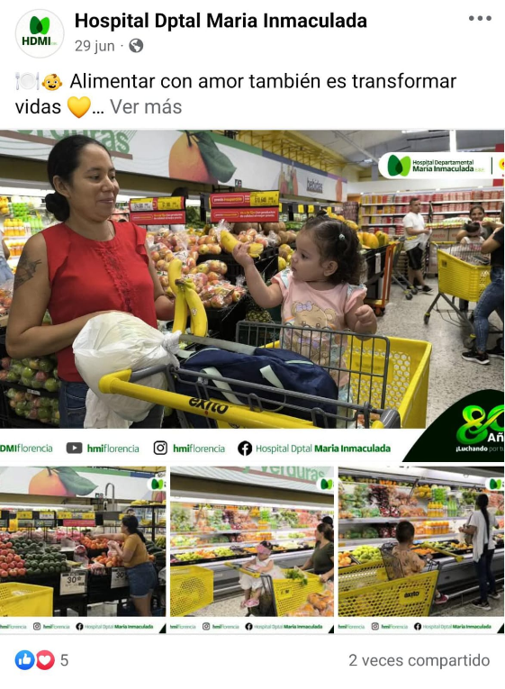 |  | https://x.com/HDMIflorencia/status/1939420421188919614?t=c5Uocg7fWfPdyTn31Axd_A&s=19
 |  | https://www.instagram.com/p/DLf17pswC/?igsh=ZXNhOTZmNjYxZHls
 |  | https://www.facebook.com/share/p/1AjthQTPxY/
JULIO

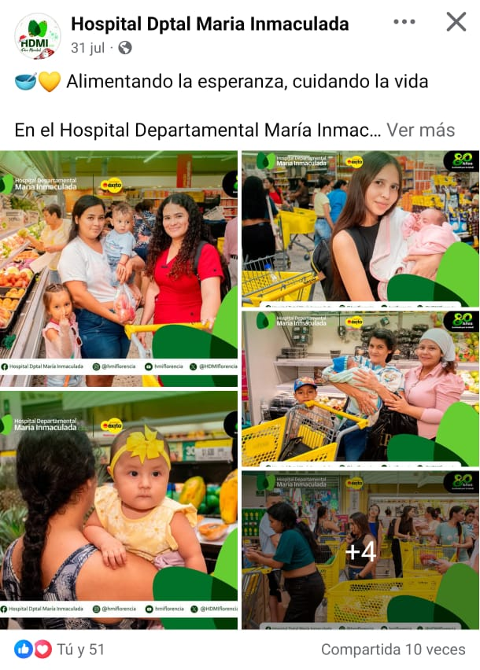  Z |  | https://www.facebook.com/share/p/1JGJwgAzaD/
 |  | https://www.facebook.com/share/p/1JGJwgAzaD/
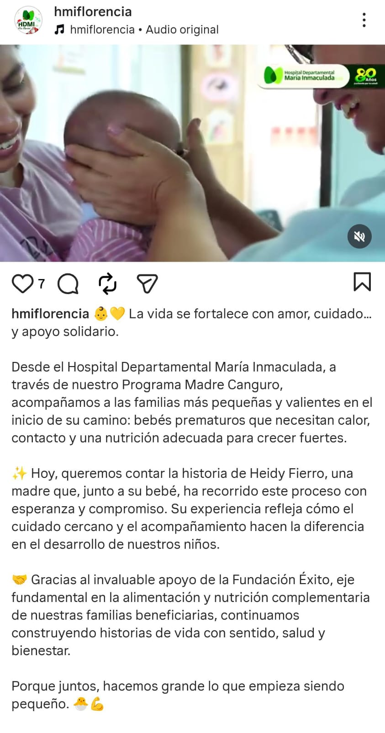 |  | https://www.facebook.com/share/v/16txWLT5sU/
 |  | https://www.instagram.com/reel/DM1HdHwBL8w/?igsh=MWQwYnk4YnJyMnJ0cw==
AGOSTO
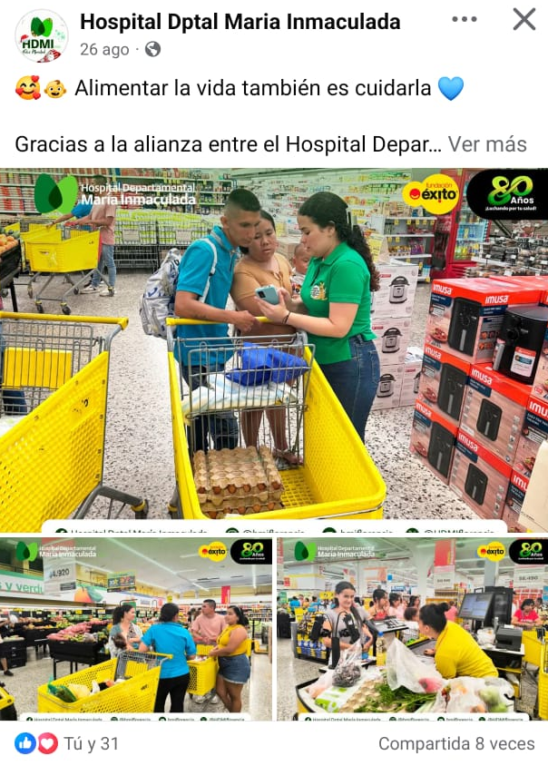 |  | https://www.facebook.com/share/p/1GZ9StJpnp/
 |  | https://www.instagram.com/p/DN02EUjWjvf/?utm_source=ig_web_copy_link&igsh=MzRlODBiNWFlZA==
 |  | https://x.com/HDMIflorencia/status/1960386116718068156
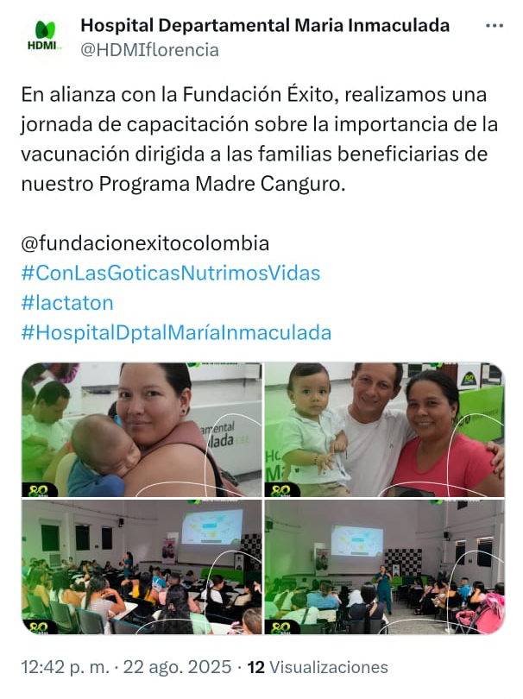 |  | https://www.facebook.com/share/p/1JXvdpKUVC/
 |  | https://www.instagram.com/p/DNqotyIg6hW/?utm_source=ig_web_copy_link&igsh=MzRlODBiNWFlZA==
 |  | https://x.com/HDMIflorencia/status/1958947886617505974
SEPTIEMBRE

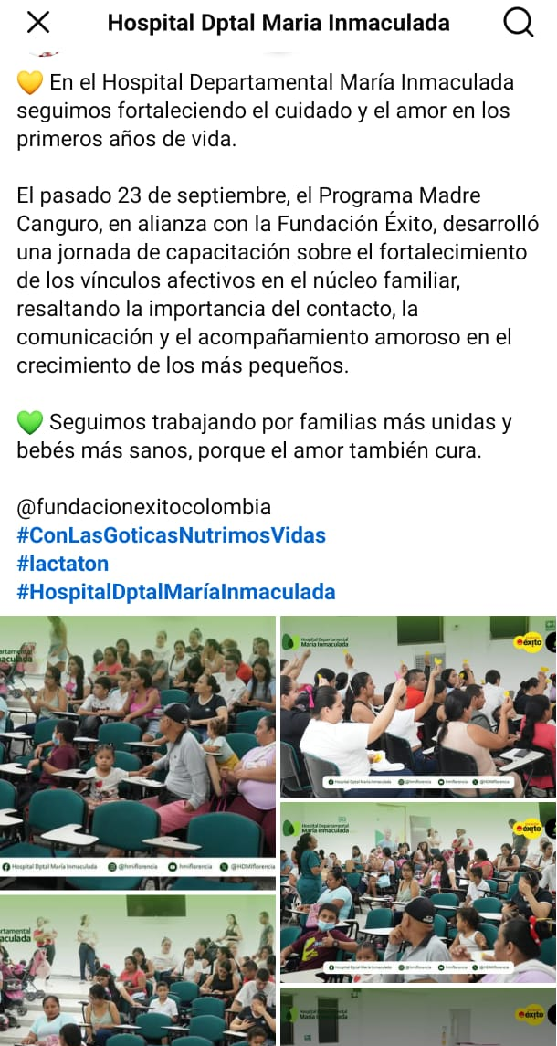 |  | https://www.facebook.com/share/p/17KGjze6Ya/
 |  | https://x.com/HDMIflorencia/status/1975339693043793922
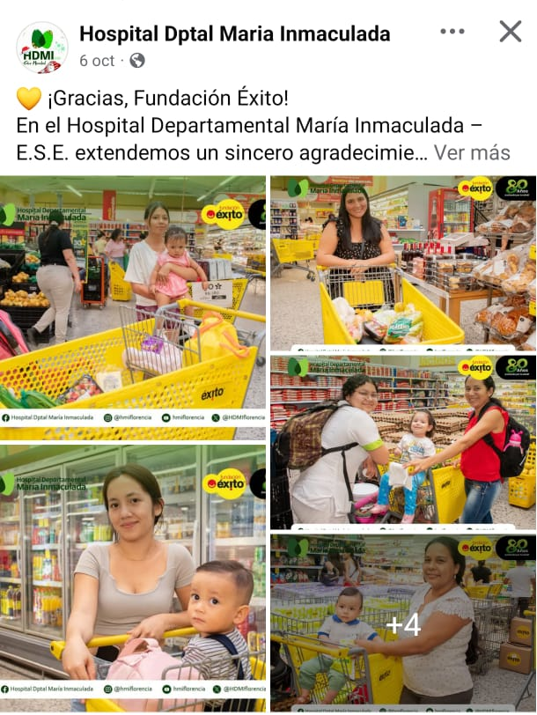 |  | https://www.facebook.com/share/p/1C5SRQ4GvJ/
 |  | https://x.com/HDMIflorencia/status/1975343141873140153
OCTUBRE
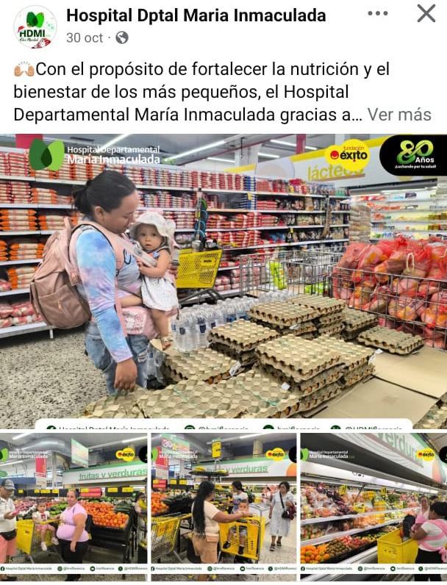 |  | https://www.facebook.com/share/p/17ZHGgonFS/?mibextid=wwXIfr
 |  | https://www.instagram.com/p/DQchbjbgYlE/?igsh=bDRvNHhwcW1lamUw
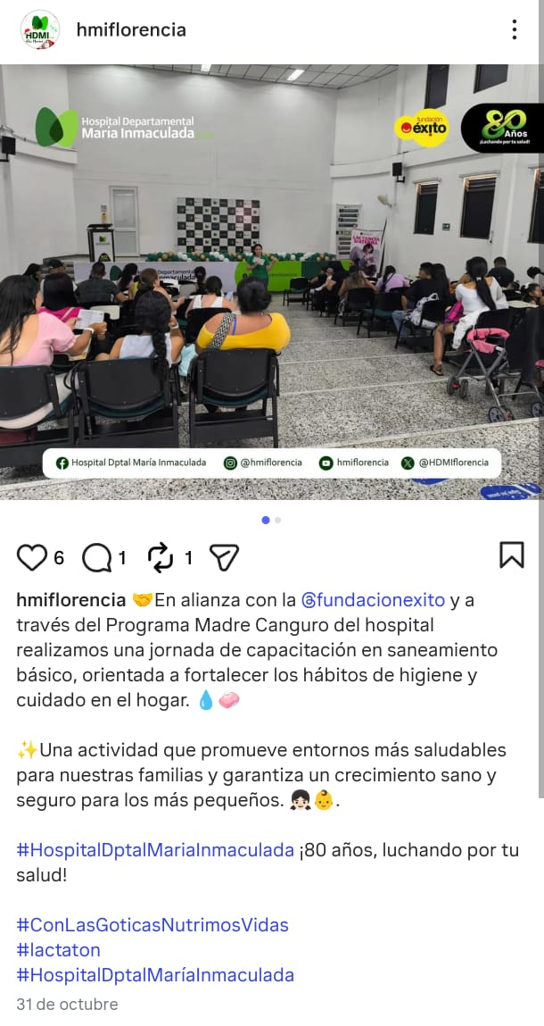 |  | https://www.facebook.com/share/p/17DqvQA1iP/?mibextid=wwXIfr
 |  | https://www.instagram.com/p/DQeq6nMDWvN/?igsh=ZGc0NHI1b3RlYXZs
NOVIEMBRE
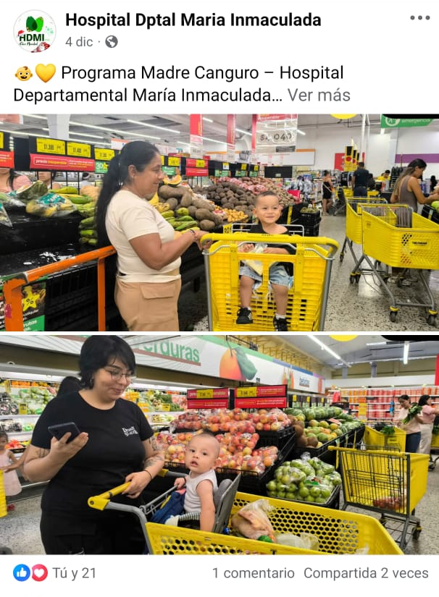 |  | https://www.facebook.com/share/p/1CvdDTB2gT/
 |  | https://www.instagram.com/p/DR2ppzWAQ-H/?utm_source=ig_web_copy_link&igsh=MzRlODBiNWFlZA==
 |  | https://x.com/HDMIflorencia/status/1996668664938946645?s=20
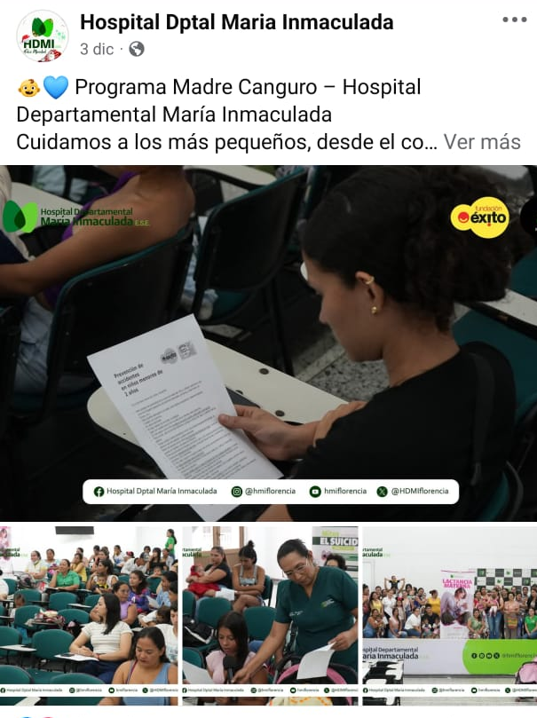 |  | https://www.facebook.com/share/p/17XXjfFFid/
 |  | https://www.instagram.com/p/DRz-QUPgT40/?utm_source=ig_web_button_share_sheet&igsh=MzRlODBiNWFlZA==
 |  | https://x.com/HDMIflorencia/status/1996291752198906072?s=20

